بسم الله الرحمن الرحيم
University: Al-Nahrain
College: Medicine
Department: Chemistry and Biochemistry
Stage: Second / Second semester
Lecturer name: Dr. Omar F. Abdul-Rasheed, Dr. Rayah Baban and Lecturer Dr. Mohammad Umran
Qualification: Assistant Professor
Place of work: Chemistry and Biochemistry Department

Republic of Iraq
The Ministry Of Higher Education
& Scientific Research
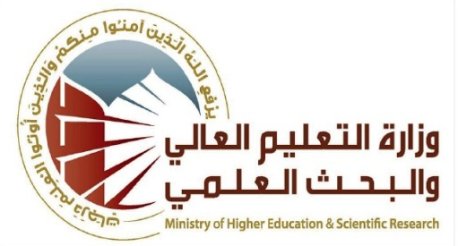

Flow up of implementation celli pass play
Course Instructor | Dr. Omar F. Abdul-Rasheed
E-mail | Omar_rasheed39@yahoo.com
Title | Clinical Chemistry
Course Coordinator | Dr. Raid J. Mohammad
Course Objective | The program involves: changes during different disease states and general consequences. There is a stress on the :  - Abnormal metabolism of macromolecules and pathological changes in the function of liver, kidney, different hormones with the clinical interpretation of laboratory findings.  - Use of enzymes in clinical diagnosis and prognosis, isoenzymes, their clinical significance.  - Porphyrin metabolism, and disorders, haemoglobinopathies, disorders of iron metabolism and significance of related laboratory tests.  - Cancer chemistry and tumor markers and their importance in clinical diagnosis and prognosis.  To have some experience in biochemical techniques in order to appreciate the practical problem of clinical biochemistry as a diagnostic tool and to improve the problem- solving skills through collaborative and individual reflection and analysis.
Course Description | Type here course description
Textbook | Lecture notes of Clinical Chemistry
Course Assessments | Term Tests | Laboratory | Quizzes | Project | Final Exam
 | (40%) | (15%) | - | - | (45%)
General Notes | Type here general notes regarding the course

University: Al-Nahrain
College: Medicine
Department: Chemistry and Biochemistry
Stage: Second/ Second semester
Lecturer name: Dr. Omar F. Abdul-Rasheed, Dr. Rayah Baban and Lecturer Dr. Mohammad Umran
Qualification: Assistant Professor
Place of work: Chemistry and Biochemistry Department

Republic of Iraq
The Ministry Of Higher Education
& Scientific Research

Course Weekly Outline
Week | Date | Topics Covered | Lab. Experiment Assignments | Notes
1 |  | Integration of Metabolism(I) |  | Dr. Omar F. Abdul-Rasheed
2 |  | Integration of Metabolism(II) |  | Dr. Omar F. Abdul-Rasheed
3 |  | Carbohydrate metabolism disorders (I) |  | Dr. RayahBaban
4 |  | Carbohydrate metabolism disorders (II) |  | Dr. RayahBaban
5 |  | Lipid metabolism disorders(I) |  | Dr. Omar F. Abdul-Rasheed
6 |  | Lipid metabolism disorders (II) |  | Dr. Omar F. Abdul-Rasheed
Mid – Term Exam.
7 |  | Amino acid and protein disorders |  | Dr. Mohammad Umran
8 |  | Renal Function tests |  | Dr. RayahBaban
9 |  | Water and electrolyte metabolism |  | Dr. RayahBaban
10 |  | Acid base balance disorders(I) |  | Dr. RayahBaban
11 |  | Acid base balance disorders(II) |  | Dr. RayahBaban
12 |  | Calcium and phosphorus metabolism |  | Dr. Omar F. Abdul-Rasheed
13 |  | Iron metabolism and porphyria(I) |  | Dr. Mohammad Umran
14 |  | Iron metabolism and porphyria(II) |  | Dr. Mohammad Umran
15 |  | Tumor markers |  | Dr. Mohammad Umran
INSTRUCTOR Signature: Dean Signature:

