Department of Surgery

flail chest management

Done By: Stagiaire Batool Ali Kadhum

Supervised By: Dr. yaser Aamar

Year 2017-2018

Acknowledgement

I would like to express my sincere appreciation and gratitude to my supervisor Dr.Yaser Aamer for his help .

And I dedicate this work to my mother for her support and my dear husband for his ultimate help, guidance and support

List of Contents

- Abstract………………………………………………………...3
- Introduction……………….……………………………………4
- Patients and Methods………………………………...………...7
- Results……………………………………………………….....8
- Discussion…………………………………………………...….9
- Conclusions……………………………………………….…...12
- Recommendations……………………………………………..13
- References…………………………………………………….14

Abstract

Background:
Severe blunt injury to the chest continues to be one of the leading causes of morbidity and mortality in both young and old trauma victims. Flail chest is one of the worst subset of these injuries and is likely the most common serious injury to the thorax seen by clinicians. Multiple care patterns and treatment modalities have emerged, many based on anecdotal clinical observation and evidence. Within the last 20 years, more rigorous scientific methods have been applied to the problem of flail chest, in both the clinical setting and laboratory. More advanced radiologic work-up with multi-slice computed tomography (MSCT) scanners is increasing the frequency of diagnosis of this problem. This article reviews the most salient data of the recent literature and discusses some of the diagnostic and treatment options that are now available in the treatment of flail chest.

Objective:
to evaluate the frequency of flail chest cases among chest trauma patient in al_Emamain al_kadhemian teaching hospital ,it's management and prognosis.

Methods:
A retrospective research carried out at al-Emamain al_Kadhemain teaching hospital on 38 patients with flail chest from the first of January 2016 till the first of January 2018.

Results:
this study done on total of 188 chest trauma patients admitted to the thoracic surgery unit during the time period studied, 38 of those patients had flail chest injury. 14(36.8%) of the patients were aged 21-30 years followed by 11 (28.9%) patients were aged 10-20 years. Male predominance was noticed 26(68.4%) cases. Most common type of trauma was blunt trauma in 28(73.7%) cases. Most common presentation was chest pain in 22(57.9%)cases, followed by shortness of breath in 16 (42.1%)cases .

Conclusions:
Flail chest injuries cause significant morbidity, especially in multiply injured patients. Standard treatment is typically focused on the underlying lung injury and involves pain control and positive pressure ventilation. Several studies suggest improved short- and long-term outcomes following operative stabilization of the flail segments. Despite these studies, flail chest fixation remains a largely underutilized procedure.

Keywords:
Flail chest, Rib fracture, chest tube ,thoracotomy ,Surgical stabilization.
INTRODUCTION (1)

- Thoracic injury is currently the second leading cause of trauma-related death and rib fractures are the most common of these injuries.
- Flail chest, as defined by fracture of three or more ribs in two or more places, continues to be a clinically challenging problem.
- The underlying pulmonary contusion with subsequent inflammatory reaction and right-to-left shunting leading to hypoxia continues to result in high mortality for these patients.

Pathophysiology of Flail Chest :
- Flail chest results when a compressive force is applied to the chest wall. The thorax can withstand 20 percent volume compression before a rib will fracture.
- The mechanical effects of fractured ribs on pulmonary function are rather predictable.
- The pain that results from movement at the fracture site leads to splinting of the intercostal muscles.
- These changes in pulmonary mechanics of the chest wall allow for atelectasis to develop and also impair the patient’s ability to cough and clear secretions.
- Both of these changes potentiate the underlying pathophysiology of an associated pulmonary contusion.
- In addition, afferent intercostal nerve reflexes cause decreased phrenic nerve function and reduced diaphragmatic contractility and tone(2).
- Ribs may be fractured bilaterally, and hemothorax, pneumothorax, or hemopneumothorax may also be present, contributing to the development of acute respiratory failure(3).

Diagnosis :
Physical examination often leads to the initial diagnosis of rib fractures
- However, the first and second ribs are difficult to assess for fracture on clinical examination as a result of their anatomic location.
- Similarly, fractures of the 10th through 12th ribs are associated with less pain as a result of their lack of continuity with the sternum but should raise suspicion for intra-abdominal or retroperitoneal injuries.
Imaging studies facilitate the diagnosis of specific fractured ribs and also associated injuries.
- Chest radiography has a sensitivity of only 50 per cent for identifying a displaced rib fracture, and it is also unreliable for identifying a flail segment.
- computed tomography (CT), which is significantly more sensitive for detecting fractured ribs, makes CT the imaging modality of choice for evaluating injured patients with major thoracic injuries. In addition to revealing rib fractures, thoracic CT scan also allows for the diagnosis of pulmonary contusion and assessment of the severity of injured lung parenchyma(4).

Current Management :
Non-operative
- Selective management therapies target the underlying pulmonary contusion and attempt to mitigate the complications associated with the flail segment, including pain, atelectasis, and compromised pulmonary hygiene.
- To treat the underlying pulmonary contusion, the goal of fluid resuscitation is to maintain euvolemia by preventing hypovolemia and fluid overload (5).
- Clearing pulmonary secretions and preventing infection is done through maintaining adequate pulmonary clearance with such techniques as suctioning, inspiratory spirometry, and intermittent positive-pressure (noninvasive) ventilation to clear secretions (6) .
- Adequate analgesia is the primary therapy that has been shown to allow for effective pulmonary mechanics, minimizing atelectasis while maintaining clearance of secretions (7).
- The combination of effective analgesia and pulmonary hygiene, coupled with treatment of the underlying pulmonary contusion, allows for maintenance of pulmonary function and avoidance of mechanical ventilation
Operative
- surgical fixation has become a more common and acceptable practice.
- The most common indications for surgical stabilization are
- failure to wean from mechanical ventilation,
- inability to provide adequate pain control,
- and the need for restoration of volume loss.
- These losses occur when the fractured rib edges are not in apposition and thoracic volume is subsequently reduced (8) (9) .

- Most surgeons prefer to fixate fractures involving the lateral and anterior surfaces of the ribs as a result of easier dissection and exposure through a single posterolateral thoracotomy incision.
- The effect of a concomitant pulmonary contusion on pulmonary function should also be considered when selecting patients for surgical stabilization.
- Several studies have shown that rib fixation does not provide short-term benefits when the patient requires prolonged mechanical ventilation for management of a pulmonary contusion (10) (11).
More recently, operative stabilization of flail chest has been advocated as a method to reduce the duration of critical care support traditionally required for these severe chest wall injuries
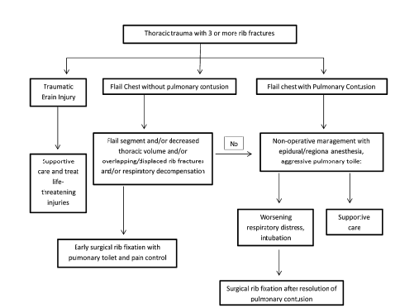

Patients& method

This is a retrospective population-based study that included total of 188 chest trauma patients who underwent Al-Imamein Al-Kadhimein Medical City Thoracic surgery unit from the first of January 2016 till the first of January 2018.
Of those 188 chest trauma patients, 38 patients had flail chest
Regarding those 38 patients with flail chest ,The following data & records were taken into consideration:-
the Age of the patients, Sex ,occupation ,Type of trauma (blunt or penetrating), presentation ,associated injuries, Management taken( conservative or chest tube or thoracotomy), ICU admission, duration of hospitalization, complications and prognosis.
The statistical analysis and table arrangement was done using IBM SPSS statistics® (6) and Microsoft Office Excel 2007®.
The results of the research were compared to other similar studies around the world and causes for variations suggested. Conclusions were based on the results of this study and recommendations made.

.
Results

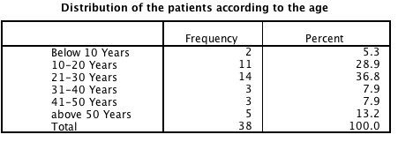

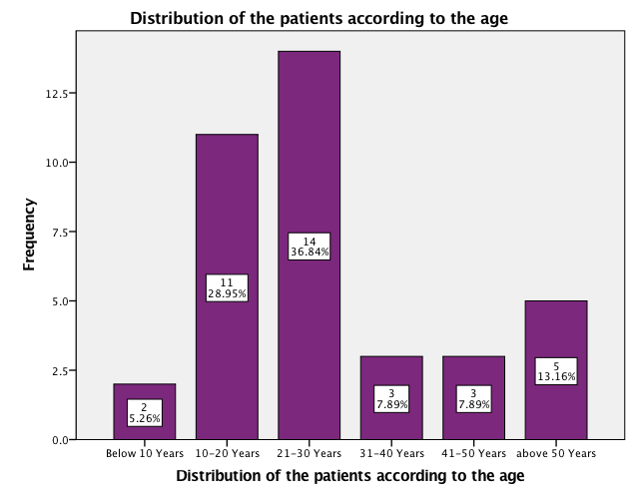

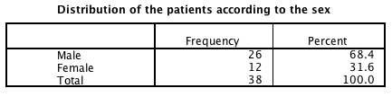

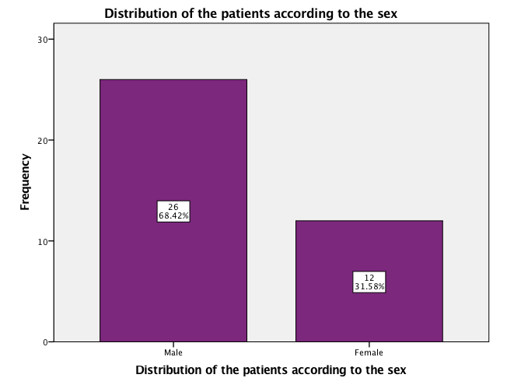

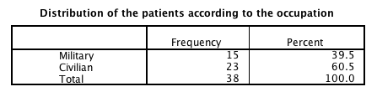

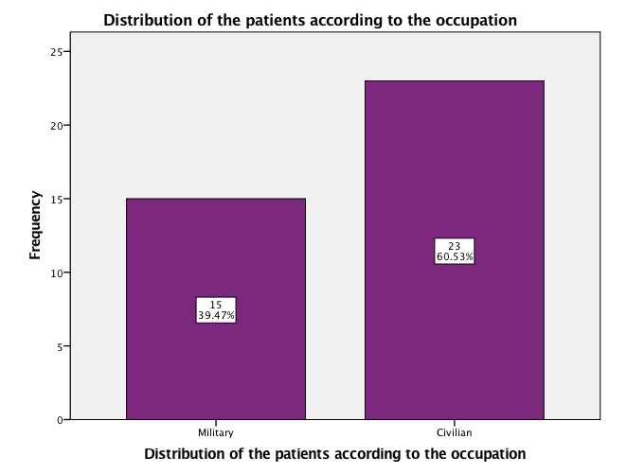

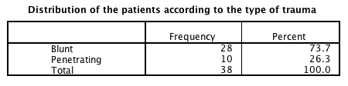

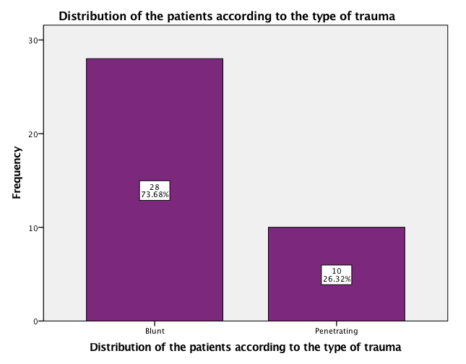

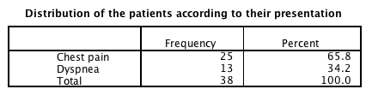

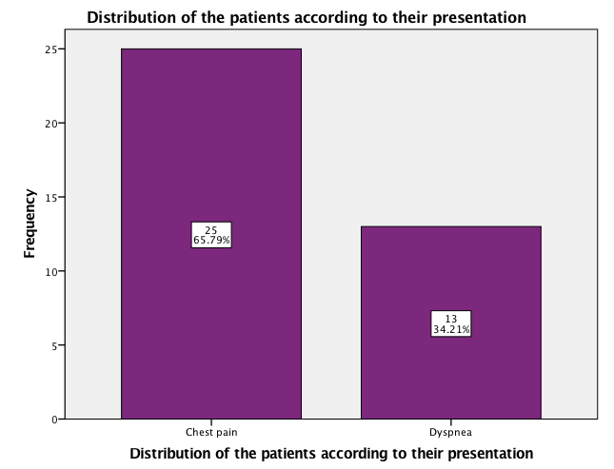

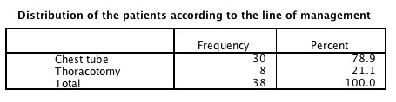

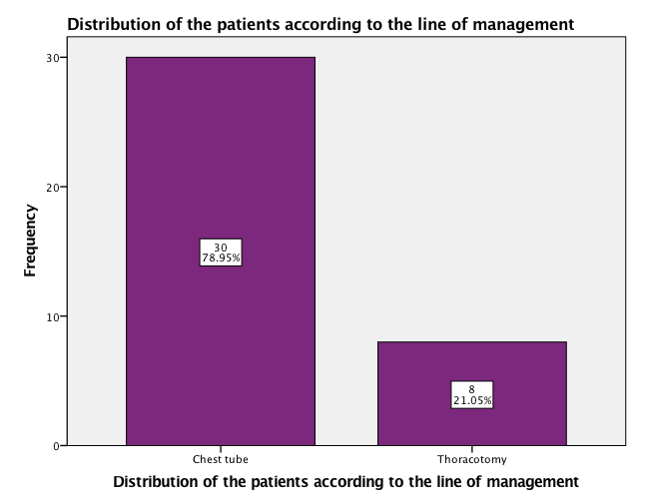

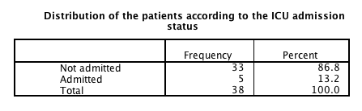

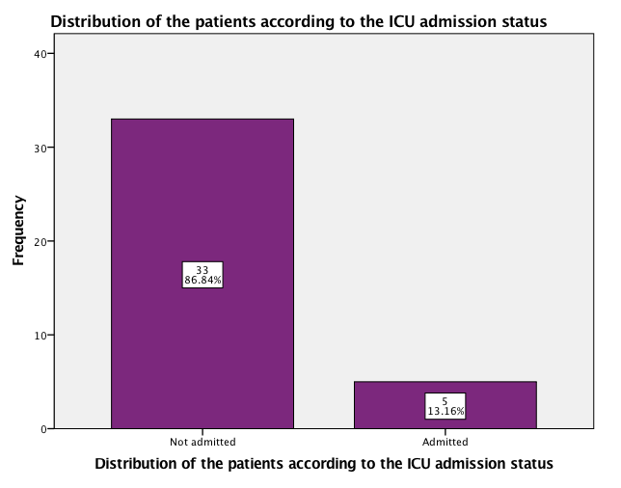

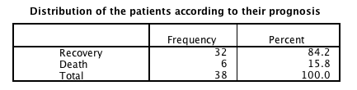

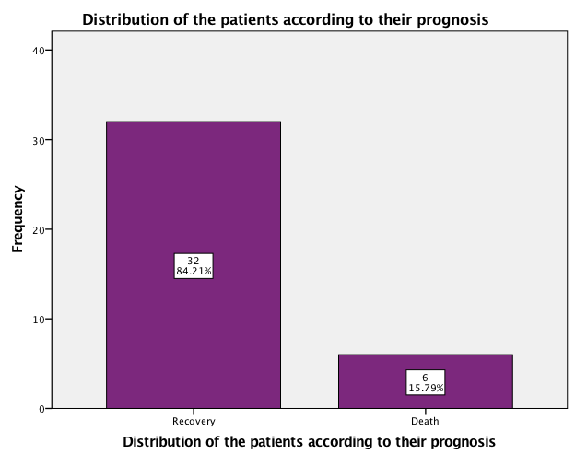

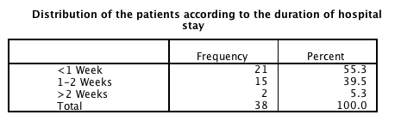

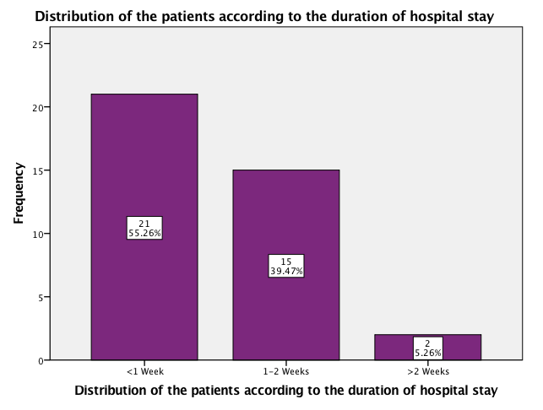

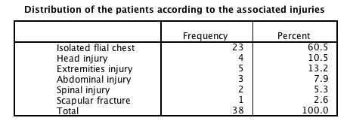
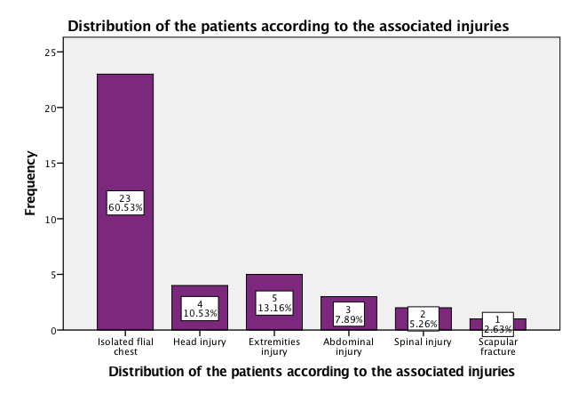

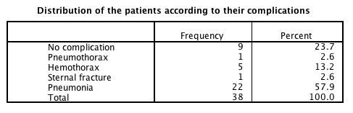

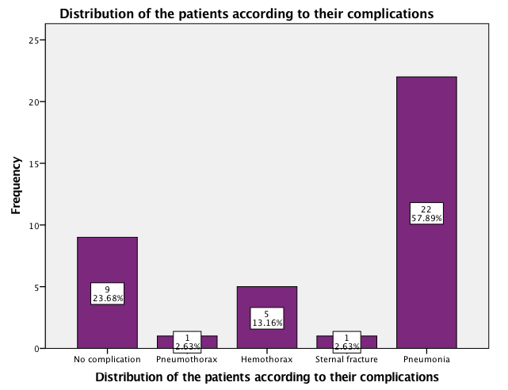

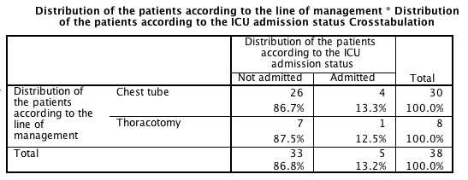
P value: 0.950599

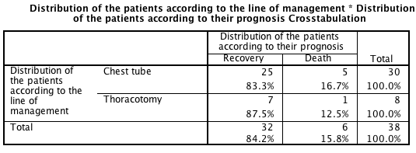
P value: 0.773984
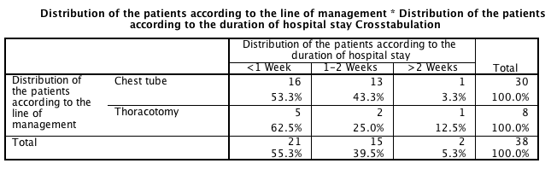
P value: 0.439960

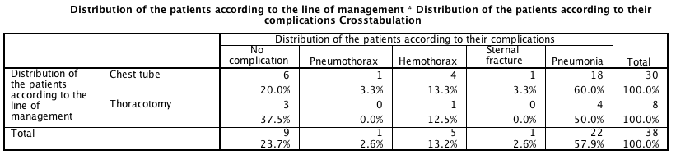
P value: 0.833276

The study showed that The commonest age group affected was
21-30 years in 14 cases (36.8%) .
11 (28.9%) patients were aged 10-20 years
5(13.2%) patients were aged above 50 years.
3(7.9%) patients were aged 31-40 years.
3(7.9%) patients were aged 41-50 years.
2(5.3%) patients were aged below 10 years.

flail chest was more common in males 26 (68.4%) patients compared to female 12( 31.6%) patients .

23(60.5%) patients were civilian and 15(39.5%) were military.

The commonest type of trauma was blunt trauma in 28 (73.7%) patients while penetrating trauma was in 10(26.3%) patients.

The most common presentation was chest pain in 22 (57.9%)patients followed by shortness of breath in 16 (42.1%) patients.

isolated flail chest was found in 23 (60.5%) patients while it was associated with other injuries in 15 (39.5%) patients.

The commonest therapeutic procedure was chest tube in 30 (78.9%)patients .
thoracotomy was done in 8 (21.1%) patients .

only 5 (13.2%) patients were admitted to the ICU

complication occurred in 30 (78.9%) patients and the commonest complication was pneumonia in 22 (57.9%) patients followed by hemothorax in 5(13.2%) patients.

complete recovery occurred in 32 (84.2%)patients , while death occurred in 6 (15.8%) patients.

Discussion

In this retrospective study, 38(20.2%) patients of 188 total chest trauma patients admitted to the thoracic unit in Al-Imamein Al-Kadhimein Medical City in a time period of two years , which is somewhat higher than another study done in the UK(12) in which the flail chest incidence amongst chest trauma patients was 85 (7.3%) cases of 1164 chest trauma cases in a time period of six years, this is because we are living in a war.

This study showed that the highest incidence of flail chest 14 (36.8%) cases was in patients aged 21-30 years followed by the age group 10-20 years with an incidence of 11 (28.9%) cases which is different from another study done in General Hospital of Nikea—Piraeus Greece (13) in which the majority of cases were above 50 years in 59.3% of cases. this is because most of our country's young males participate in the war against ISIS.

Regarding the gender distribution, this study showed a higher incidence in males, 26 (68.4%) patients, than in females, 12 (31.6%) patients. In the same study above (done in the Greece) (13), it was found that males had almost three times the incidence of females of having flail chest injury. And in another study done in Al-Imamein Al-Kadhimein Medical City in 2015(14) , males’ predominance was also observed with a percentage of 70% .
also in this study 23(60.5%) patients were civilian and 15(39.5%) were military . this maybe because of explosions in our country which cause more injuries to civilians ,females ,and children in comparison to other countries .

The commonest type of trauma was blunt trauma in 28 (73.7%) cases which is also the commonest type of trauma (92%) in another study done in Sweden (15) .

The most common presentation according to this study was chest pain, which was the presentation in 22 (57.9%) cases. Also In the same study done in greece (13) , it was found that the most common presentation of flail chest is chest pain and shortness of breath.

Regarding management ,30 (78.9%) patients were conservatively treated( needed thoracic drainage with chest tube). while only 8 (21.1%) patients required thoracotomy .

regarding complications of flail chest in this study :
22(57.9%) patients developed pneumonia which is somewhat higher when compared to another study done in USA(16) in which the incidence of pneumonia among flail chest patient was (43.9%) .
while 5(13.2%) cases developed hemothorax and only one (2.6%)case developed pneumothorax.

This study shows that operative management of flail chest improves the outcome of patients concerning :
* ICU admission
in this study one(12.5%) patient of total 8 patients underwent thoracotomy admitted to the ICU while 4(13.3%) patients of total 30 patients managed conservatively with chest tube admitted to the ICU .
* Duration of hospitalization
in this study 8 patients underwent thoracotomy , 5 (62.5%) of them remain in the hospital for less than one week ,while 2(25.0%) of them remain in the hospital for an average of one to two weeks and only 1(12.5%)patient of those 8 remain in the hospital for more than 2 weeks
while 30 patients treated conservatively with chest tube ,16(53.3%)of them remain in the hospital for less than one week ,while 13(43.3%) of them remain in the hospital for an average of one to two weeks and only 1(3.3%)patient of those 8 remain in the hospital for more than 2 weeks
* Complication
in this study 4(18.2%) of those patients who developed pneumonia were managed by thoracotomy while 18 (81.8%) of them were managed by chest tube .

So according to this study , operative management of flail chest will result in less ICU admission, shorter duration of hospitalization(faster recovery) and less complication especially pneumonia .

in this study death occurred in one (12.5%)case of total 8 cases underwent thoracotomy and in 5 (16.7%) cases of total 30 cases treated conservatively with chest tube , so there is no significant difference in mortality rate between operative and non-operative management of isolated flail chest cases but mortality rate increase in the presence of associated other injuries as death occurred in 2(8.7%) patients of total 23 patients with isolated flail chest while it occurred in 4(26.6%) patients of total 15 flail chest patients who had associated other injuries .

Conclusion

Despite the relatively small number of patients included, different methodologies and differences in presentation of outcomes, operative management of flail chest seems to be a promising treatment strategy that improves patients’ outcomes in various ways (result in less ICU admission, shorter duration of hospitalization and less complication especially pneumonia). However, the effect on mortality rate remains inconclusive. Therefore, research should continue to explore operative management as a viable method for flail chest injuries.

Recommendation

Based on the aforementioned analyses, in adult patients with flail chest after, we conditionally recommend operative rib ORIF compared to non-operative management: to shorten the duration of hospitalization, lessen the incidence of ICU admission and decrease complication especially pneumonia .This level of recommendation is given based on the low quality of evidence. We cannot offer a recommendation for pain control with currently available evidence.

References

(1)- Invited Commentary Contemporary Management of Flail Chest P. GEOFF VANA, M.D.,* DANIEL C. NEUBAUER, B.S.,† FRED A. LUCHETTE, M.D., M.SC.,*† From the *Department of Surgery and the †Stritch School of Medicine, Loyola University of Chicago, Maywood, Illinois

(2) -Viano D, Lau I, Asbury C. Biomechanics of the human chest, abdomen, and pelvis in lateral impact. Accid Anal Prev 1989;21:553–74

(3) -7. Jones KM, Reed RL II, Luchette FA. The ribs or not the ribs: which influences mortality. Am J Surg 2011;202:598–604.

(4)- Miller PR, Croce MA, Bee TK, et al. ARDS after pulmonary contusion: accurate measurement of contusion volume identifies high-risk patients. J Trauma 2001;51:223–30

(5)- McGwin G, Melton SM, May AK, et al. Long-term survival in the elderly after trauma. J Trauma 2000;49:470–6.

(6)- Hagen K. Multiple rib fractures treated with a Drinker respirator: a case report. JBJS Case Connect 1945;27:330–4.

(7) -Flagel B, Luchette FA, Reed RL, et al. Half a dozen ribs: the breakpoint for mortality. Surgery 2005;138:717–25.

(8)- Mayberry JC, Terhes JT, Ellis TJ, et al. Absorbable plates for rib fracture repair: preliminary experience. J Trauma 2003;55: 835–9.

(9)- Engel C, Krieg JC, Madey SM, et al. Operative chest wall fixation with osteosynthesis plates. J Trauma 2005;58:181–6.

(10)- . Kroell C, Schneider D, Nabum A. Impact tolerance and response of the human thorax. Stapp Car Crash J 1974;18:383–457.

(11)- Richardson JD, Franklin GA, Heffly S, et al. Operative fixation of chest wall fractures: an underused procedure? Am Surg 2007;73:591–7

(12)- Prevalence of chest trauma, associated injuries and mortality: a level I trauma centre experience ,Veysi T. Veysi,¹ Vassilios S. Nikolaou,² Christos Paliobeis,²Nicolas Efstathopoulos,³ and Peter V. Giannoudis^{2,4}

(13) -Management of 150 flail chest injuries: analysis of risk factors affecting outcome
Kalliopi, Athanassiadi, Michalis ,GerazounisNikolaos, Theakos

(14)-Al-Nahrain University, College of Medicine, Library archive, Department of surgery, Stagiaire Noor Arif , chest trauma , year 2015.

(15)- Surgical treatment of multiple rib fractures and flail chest in trauma: a one-year follow-up study, Eva-Corina Caragounis Email author View ORCID ID profile , Monika Fagevik Olsén , David Pazooki and Hans Granhed.

(16)- Flail chest injury: are we making any progress? Cannon RM¹, Smith JW, Franklin GA, Harbrecht BG, Miller FB, Richardson JD.

