Chapter one
Introduction

INTRODUCTION:
PHARYNX
The pharynx is the superior expanded part of the alimentary system posterior to the nasal and oral cavities, extending inferiorly past the larynx. The pharynx extends from the cranial base to the inferior border of the cricoid cartilage anteriorly and the inferior border of the C6 vertebra posteriorly. The pharynx is widest (approximately 5 cm) opposite the hyoid and narrowest (approximately 1.5 cm) at its inferior end, where it is continuous with the esophagus. The flat posterior wall of the pharynx lies against the prevertebral layer of deep cervical Fascia.
Parts of pharynx (FIGURE 1 and 2).
The pharynx is divided into three parts:
• Nasopharynx: posterior to the nose and superior to the soft palate.
• Oropharynx: posterior to the mouth.
• Laryngopharynx: posterior to the larynx

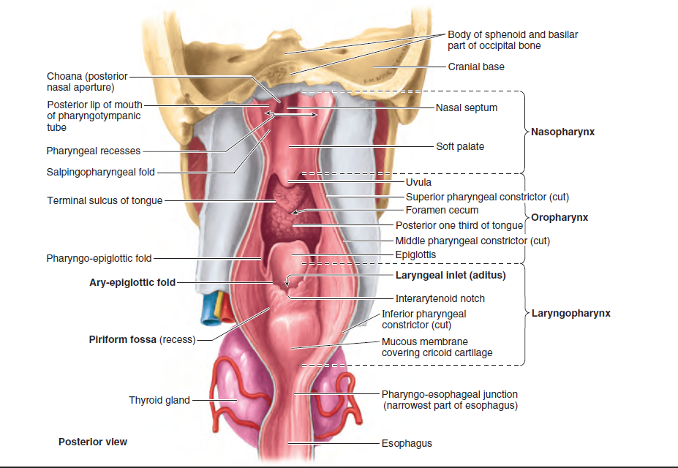
FIGURE 1: Anterior wall of pharynx. In this dissection, the posterior wall has been incised along the midline and spread apart. Openings in the anterior wall communicate with the nasal, oral, and laryngeal cavities. On each side of the laryngeal inlet, separated from it by the ary-epiglottic fold, a piriform fossa (recess) is formed by the invagination of the larynx into the anterior wall of the laryngopharynx.⁽²⁾

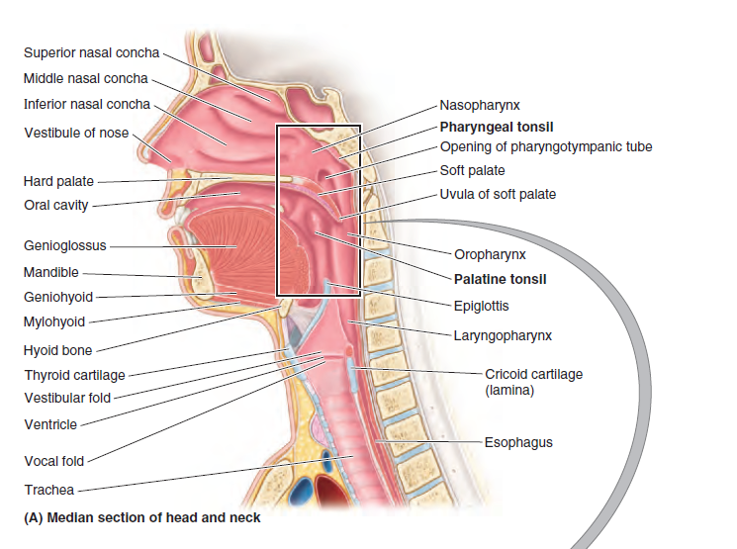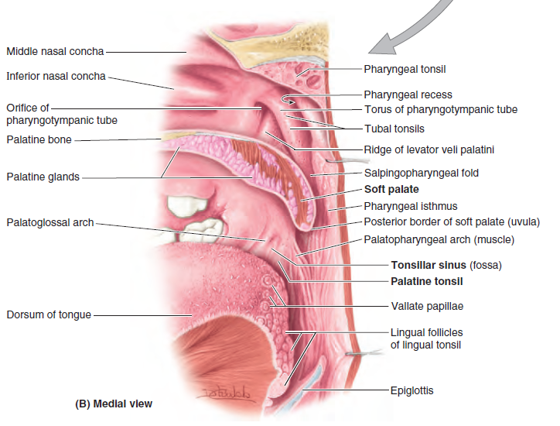
FIGURE 2: Internal aspect of lateral wall of pharynx. A. The upper respiratory passages and alimentary canal in the right half of a bisected head and neck are shown. The rectangle indicates the location of the section shown in part B. B. A closer view of the nasopharynx and oropharynx, which are separated anteriorly by the soft palate, is provided. The posterior border of the soft palate forms the anterior margin of the pharyngeal isthmus through which the two spaces communicate posteriorly.⁽³⁾
The nasopharynx has a respiratory function; it is the posterior extension of the nasal cavities .The nose opens into the nasopharynx through two choanae (paired openings between the nasal cavity and the nasopharynx). The roof and posterior wall of the nasopharynx form a continuous surface that lies inferior to the body of the sphenoid bone and the basilar part of the occipital bone.⁽¹⁾
Anatomy and Physiology of nasopharynx

The nasopharyngeal tonsils, commonly called "adenoids", is situated <It the junction of the roof and posterior wall of the nasopharynx. It is composed of vertical ridges of lymphoid tissue separated by deep clefts and covered by ciliated columnar epithelium. Unlike palatine tonsils,
adenoids have no crypts and no capsule. Adenoid tissue is present at birth, shows physio logical enlargement up to the age of six years, and then tends to atrophy at puberty and almost completely disappears by the age of 20.
Adenoids receive their blood supply from :
1- Ascending palatine branch of facial.
2- Ascending pharyngeal branch of external carotid.
3- Pharyngeal branch of the third part of maxillary artery.
4- Ascending cervical branch of inferior thyroid artery of thyrocervical trunk.

Lymphatic Drainage
Lymphatics of the nasopharynx, including those of the adenoids and pharyngeal end of eustachian tube, drain into upper deep cervical nodes either directly or indirectly through retropharyngeal and parapharyngeal lymph nodes. They also drain into spinal accessory chain of nodes in the posterior triangle of the neck.⁽⁴⁾

Oropharynx
The oropharynx has a digestive function. It is bounded by the soft palate superiorly, the base of the tongue inferiorly, and the palatoglossal and palatopharyngeal arches laterally
Anatomy of tonsils
The palatine tonsils are collections of lymphoid tissue on each side of the oropharynx in the interval between the palatine arches .The tonsil does not fill the tonsillar sinus (fossa) between the palatoglossal and palatopharyngeal arches in adults. The submucosal tonsillar bed, in which the palatine tonsil lies, is between these arches .The tonsillar bed is formed by the superior pharyngeal constrictor and the thin, fibrous sheet of pharyngobasilar fascia .This fascia blends with the periosteum of the cranial base and defines the limits of the pharyngeal wall in its superior part. ⁽⁵⁾
Blood Supply
l. Tonsillar branch of facial artery. This is the main artery.
2. Ascending pharyngeal artery from external carotid.
3. Ascending palatine, a branch of facial artery.
4. Dorsal linguae branches of lingual artery.
5. Descending palatine branch of maxillary artery.
Venous Drainage
Veins from the tonsils drain into paratonsillar vein which joins the common facial vein and pharyngeal venous plexus.
Lymphatic Drainage
Lymphatics from the tonsil pierce the superior constrictor and drain into upper deep cervical nodes particularly the jugulodigastric (tonsillar) node situated below the angle of mandible

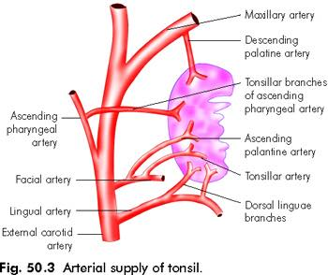
FIGURE 3: Arterial supply of the tonsils
Nerve Supply
Lesser palatine branches of sphenopalatine ganglion (CN V) and glossopharyngeal nerve provide sensory nerve supply.
Histology
Primarily, the tonsil consists of (a) surface epithelium which is continuous with the oropharyngeal lining; (b) crypts which are tube- like invaginations from the surface epithelium; and (c) the lymphoid tissue. Acute infections of tonsil may involve these components.
Pathology of tonsils
Classified into
1-Acute
2- Chronic
Type of acute tonsillitis
1. Acute catarrhal or superficial tonsillitis. Here tonsillitis is a part of generalised pharyngitis and is mostly seen in viral infections
2- Acute follicular tonsillitis. Infection spreads into the crypts which become filled with purulent material, presenting at the openings of crypts as yellowish spots
3-Acute parechymatous tonsillitis Here tonsil substance is affected. Tonsil is uniformly enlarged and red.
4. Acute membranous tonsillitis. It is a stage ahead of acute follicular tonsillitis when exudation from the crypts coalesces to form a membrane on the surface of tonsil.
The symptoms vary with severity of infection. The predominant symptoms are:
1. Sore throat.
2. Difficulty in swallowing..
3. Fever. It may vary from 38 to 40°C and may be associated with chills and rigors. Sometimes, a child presents with an unexplained fever and it is only on examination that an acute tonsillitis is discovered.
4. Earache. It is either referred pain from the tonsil or the result of acute otitis media which may occur as a complication.
5. Constitutional symptoms. They are usually more marked than seen in simple pharyngitis and may include headache, general body aches, malaise and constipation. There may be abdominal pain due to mesenteric lymphadenitis simulating a clinical picture of acute appendicitis.
Signs
1. Often the breath is foetid and tongue is coasted.
2. There is hyperaemia of pillars, soft palate and uvula
3. Tonsils are red and swollen with yellowish spots of purulent material presenting at the opening of crypts (acute follicular tonsillitis) or there may be a whitish membrane on the medial surface of tonsil which can be easily wiped away with a swab (acute membranous tonsillitis). The tonsils may be enlarged and congested so much so that they almost meet in the midline along with some oedema of the uvula and soft palate (acute parenchymatous tonsillitis).
4. The jugulodigastric lymph nodes are enlarged.
Chronic tonsillitis
Chronic follicular tonsillitis. Here tonsillar crypts are full of infected cheesy material which shows on the surface as yellowish spots
Chronic parenchymatous tonsillitis . There is hyperplasia of lymphoid tissue. Tonsils are very much enlarged and may interfere with speech , deglutition and respiration Attacks of sleep apnea may occur. Longstanding Cases develop features of cor pulmonale.
Clinical Features
1. Recurrent attacks of sore throat at" acute tonsillitis.
2. Chronic irritation in throat with cough.
3. Bad taste in mouth and foul breath (halitosis) due to pus in crypts.
4 Thick speech, difficulty in swallowing and choking spells at night (when tonsils are large and obstructive).
Signs
1. Tonsils may show varying degree of enlargement.
Sometimes they meet in the midline (chronic parenchymatous type).
2- Tonsilloliths are more often seen in adults and give rise to local discomfort or foreign body sensation. They are easily diagnosed by palpation or gritty feeling on probing.
3- tonsillar abscess. It is accumulation of pus within the substance of tonsil. It usually follows blocking of the crypt opening in acute follicular tonsillitis. There is marked local pain and dysphagia. Tonsil appears swollen and red.
4-Tonsillar cyst.⁽⁶⁾
Adenoidectomy and tonsillectomy.
1-Adenoidectomy
Adenoidectomy may be indicated alone or in combination with tonsillectomy. In the latter event, adenoids are removed first and the nasopharynx packed before starting tonsillectomy.
- Indications
1. Adenoid hypertrophy causing snoring, mouth breathing, sleep apnea syndrome or speech abnormalities
2. Recurrent rhinosinusitis.
3. Chronic secretory otitis media associated with adenoid hyperplasia.
4. Recurrent ear discharge in benign CSOM associated with adenoiditis/adenoid hyperplasia.
5. Dental malocclusion. Adenoidectomy does not correct dental abnormalities but will prevent its recurrence after orthodontic treatment
- Contraindications
1. Cleft palate or submucous palate. Removal of adenoids causes velopharyngeal insufficiency in such cases.
2. Haemorrhagic diathesis.
3. Acute infection of upper respiratory tract
- Complications
l. Haemorrhage, usually seen in immediate postoperative period. Nose and mouth may ' be full of blood or the only indication may be vomitus of dark coloured blood which the patient had been swallowing gradually in post-operative period. Rising pulse rate is another indicator. Treatment is same as for per-operative haemorrhage. Postnasal pack under general anaesthesia is often required.
2. Injury to eustachian tube opening.
3. Injury to pharyngeal musculature and vertebrae. This is due to hyperextension of neck and undue pressure of curette. Care should be taken when operating patients of Down's syndrome as 10-20% of them have atlantoaxial instability.
4. Velopharyngeal insufficiency.
5. Nasopharyngeal stenosis due to scarring.
6. Recurrence. This is due to regrowth of adenoid tissue left behind⁽⁷⁾

2-Tonsillectomy

Absolute Indications for Tonsillectomy
1-Chronic or recurrent tonsillitis
A- Seven episodes in 1 year, or
B-Five episodes per year for 2 years, or
C-Three episodes per year for 3 years, or
D-Two weeks or more of lost school or work in a year
2-Tonsillitis causing febrile convulsions
3-Cardiac valvular disease associated with recurrent streptococcal tonsillitis.
4-Hypertrophy of tonsils causing :-
1-obstructive sleep apnea and sleep disturbances
2-Corpulmonale
Relative Indications
1- Recurrent sore throats or upper respiratory infections. (URI)
2-Failure to thrive
3-Chronic tonsillitis with bad taste or halitosis
4-Recurrent streptococcal tonsillitis in a patient with valvular heart disease.
5-Tonsillolithiasis⁽⁸⁾
Techniques of tonsillectomy/tonsillotomy :
Cold methods:
I Dissection and snare (most common)
II Guillotine method
III Intracapsular (capsule preserving) tonsillectomy with debrider.
IV Harmonic scalpel (ultrasound)
V Plasma-mediated oblation technique
VI Cryosurgical technique
Hot methods:
I Electrocautery
II Lasertonsillectomy or tonsillotomy (C02 or KTP)
III Coblation tonsillectomy
IV Radio frequency.
Post Tonsillectomy Complications:
Divided into early and late
Early :-
1. Primary haemorrhage. Occurs at the time of operation.
It can be controlled by pressure, ligation or electrocoagulation of the bleeding vessels.
2. Reactionary haemorrhage. Occurs within a period of 24 hours and can be controlled by simple measures such as removal of the clot, application of pressure or vasoconstrictor.
Presence of a clot prevents the clipping action of the superior constrictor muscle on the vessels which pass through it (compare post-partum uterine bleeding). If above measures fail, ligation or electrocoagulation of the bleeding vessels can be done under general anesthesia.
3. Injury to tonsillar pillars, uvula, soft palate, tongue or superior constrictor muscle due to bad surgical technique.
4. Injury to teeth.
5. Aspiration of blood.
Delayed
1. Secondary haemorrhage . Usually seen between the 5rh to 10th posroperative day. It is the result of sepsis and premature separation of the membrane. Usually, it is heralded by bloodstained sputum but may be profuse.
2-Infection
3- Lung complications
4- Scarring in soft palate and pillars
5- Hypertrophy of lingual tonsil.
Contraindications
- Hemoglobin level less than 10 g%

2. Presence of acute infection in upper respiratory tract, even acute tonsillitis. Bleeding is more in the presence of acute infection.

3. Children under 3 years of age. They are at poor surgicaI risks
.
4. Overt or submucous cleft palate
.
5. Bleeding disorders, e.g. leukaemia, purpura, aplastic anemia, haemophilia\
.
6. At the time of epidemic of polio
7. Uncontrolled systemic disease, e.g. diabetes, cardiac disease, hypertension or asthma.
8. Tonsillectomy is avoided during the period of menses ⁽⁹⁾

Management of early complications
Early bleeding
All patients should undergo an examination of the oral cavity before discharge, including examination of both tonsillar fossae to rule out the presence of a clot. A clot within a tonsillar fossa can be assumed to represent underlying bleeding. The clot should be removed and the tonsillar fossa inspected. If a clot is present or frank bleeding is visualized, either immediately postoperatively or days later, tonsillar bleeding is occurring and intervention is necessary. Vital signs, pulse and blood pressure, should be obtained immediately and monitored closely. If airway distress is present, oxygen saturation should be monitored with a pulse oximeter. The surgeon needs a headlight for examination because both hands will be required for management. Young children and uncooperative older patients will require general anesthesia, although most patients older than 5 or 6 years will tolerate a certain degree of manipulation, and general anesthesia can often be avoided in these patients. Instrumentation should be obtained, and assistance will be required. Most hospitals have prepared “T&A hemorrhage trays.” These trays should be examined before they are actually needed. The patient is best examined in a sitting position or in a semi sitting position on a stretcher .The pharynx can be sprayed with a topical anesthetic such as benzocaine, tetracaine, and benzalkonium (Cetacaine). Care must be taken to not overanesthetize the pharynx and hypopharynx because doing so can result in aspiration secondary to ablation of the laryngeal protective reflexes. In a similar manner, sedation should be either avoided or minimized. Using a tongue blade for retraction and suction, the clot can be removed from the tonsillar fossa. Even if there is no further bleeding, inpatient observation is warranted. If the bleeding point is visualized, injection of 1% lidocaine (Xylocaine) with epinephrine 1 : 100,000 into the tissue immediately adjacent to the bleeding vessel may result in cessation of the bleeding. Once an injection has been performed, cauterization with either electrocautery or silver nitrate may be efficacious in controlling the bleeding. If these maneuvers are not successful, a figure-of-eight suture may be placed. This requires an exceptionally cooperative patient and significant hand-eye coordination on the part of the surgeon for accomplishment in an awake patient. If the previously described efforts are unsuccessful and bleeding continues, if the patient is uncooperative, or if the bleeding is massive, general anesthesia will be required. Anesthetizing a patient with postoperative tonsillar bleeding can be a challenge for the anesthetist. The surgeon should insist that the most experienced and skillful anesthesiologist be available for the induction. The patient may be hypovolemic, combative, and suffering airway compromise because of the volume of blood in the mouth. Moreover, because the stomach is usually filled with blood and other secretions, the risk of perioperative aspiration is significant. Control of hemorrhage with direct pressure to permit fluid resuscitation and suctioning of blood from the pharynx may be lifesaving. Care must be taken to avoid aspiration of blood and stomach contents by overzealous local and topical anesthesia of the pharynx, hypopharynx, and larynx. Patients who are hypovolemic must have their fluid and blood deficits replaced as rapidly as possible during preparation for anesthesia. The combination of hypovolemia and hypotension from anesthetic agents may produce cardiovascular arrest.⁽¹⁰⁾
2- Nausea and vomiting
Opiates are well known a cause of nausea and vomiting by stimulation of chemoreceptors. This mainly can be controlled by a single IV intraoperative dose of Dexamethasone between 0.15-1 mg/kg halves the risk of vomiting⁽¹¹⁾ . Prophylactic ondansetron works better than metaclopramide in reducing post- operative vomiting ⁽¹²⁾

3- pain
Adequate analgesia is important in the immediate post operative care. Narcotics have a potent emetic effect and should be used with caution. Asingle dose of narcotic may be administered in the recovery phase and codein may be used in the early post operative period. Paracetamol is the drug of choice in the UK on the grounds of safety and efficacy. For some children this may not be adequate so NSAIDs are needed.⁽¹³⁾

Chapter two
Patients and methods

Patients and methods
The study was as cross sectional study including patients underwent tonsillectomy at Al-Kadhymia
Hospital from 1stof October 2017 to 1st of March 2018.
Inclusion criteria
- Patient who had tonsillectomy or adenotonsillectomy
- patient in first day post operative
- patient with cold dissection method as noted in patient operative note
- patient with normal past medical history
exclusion criteria

- subjects previously diagnosed with genetic syndromic patients (eg, Down syndrome, craniofacial anomalies, neuromuscular disorders, chromosomal abnormality, etc), coagulation disorders, or cerebral palsy.
- Patients admitted after first day for tonsillectomy complications
- Patient did surgery by other methods

History taken from the patient regarding patient data and chief complain to reach the indication for surgery

Past medical and surgical was asked to identify any risky patients
All patients had complete ent examination post operatively

Details of each patient case were obtained and followed up during the first day post-op searching for any complication he could have
- Those patient underwent preoperative clinical assessment by taking full history , full clinical examination and laboratory investigations interm of CBC , Blood sugar , renal function test , Chest x-ray , Bleeding profile and virology screen for Hepatits b and c .

- Name
- Age Sex Weight
- Chief Complaint
- History of present illness:
- Systemic Review
- Respiratory system
- Cardiovascular system
- GIT system
- RENAL System
- Central Nervous System
- Musculoskeletal
- Past medical history :-
- Past Surgical history :-
- Family history :-
- Social history :-
On Examination
- Throat
- Nose
- Ear
- On follow up
Type of Complication

Chapter three
Results

Results
Table (1) showing frequency for each one of early post tonsillectomy complication
Complication | Number | Percentage
Pain | 32 | 80%
Nausea | 23 | 57.5%
Vomiting | 11 | 27.5%
Bleeding | 2 | 5%
No complications | 6 | 15%

Table (2) Shows the frequency of presence of early complication
Presence of complications | Number | Percentage
Yes | 34 | 85%
No | 6 | 15%
Total | 40 | 100%

Table (3) shows the frequency of indications of tonsillectomy
Indications | Recurrent tonsillitis | Other causes
Percent | 80% | 20%

Table(4) show the frequency of each gender undergoing tonsillectomy
Gender | Number | Percentage
Male | 23 | 57.5%
Female | 17 | 42.5%

Table (5) shows the frequency of each age group undergoing tonsillectomy
Age Distribution | Number | Percentage
≤ 5 years | 6 | 15%
6-11 years | 29 | 72.5%
≥ 12 years | 5 | 12.5%
Total | 40 | 100%

Chapter four
Discussion

Discussion
Tonsillectomy is one of the most common procedures that is done especially in children.
Most common age group was in the 6-11 years category . this simulated the literature as in Amoils M . ⁽¹³⁾
In this study , males were more common (57%) while females were (43%) . this simulated the study that males are more commonly affected than females as in Amoils M . ⁽¹³⁾
In this study , most common indication was due to recurrent and chronic tonsillitis 80 % while 20% due to other causes . this simulated the lecture as in Zagólski O .⁽¹⁴⁾
Regarding the complications, most common complication was post operative pain (80%) and all of them of mild form . this simulated the lecture as in Steward DL. ⁽¹⁵⁾
Regarding nausea , was about (57.5%) of cases. This doesn’t simulated the study as in Zagólski O and as in Bennett A⁽¹⁴⁾⁽¹⁶⁾ . May be due to not taking prophylactic ondansetrone , or due to not taking steroid during operation
Regarding the vomiting , was about (27.5)% and this simulated the study Bennett A . ⁽¹⁶⁾
Regarding post operative bleeding was about 5% , this doesn’t simulated the study Konstantinopoulou S^{(17) .} May be due to poor hygiene , diffenet methods used or because of the small sample.

Chapter five
Conclusions and Recommendations

Conclusion
Tonsillectomy is one of the most common surgeries in pediatric age group.it's most in male and in age group between 6-11 yrs. The most common early post tonsillectomy complication was pain. The second most common was nausea, while the least one was bleeding . Post operative hemorrhage remains the most important post operative complication because it can arise in any time and it can be life threatening complication.

Recommendations
Add painkiller to all patient in first hour post tonsillectomy .
Advice to give steroids to reduce post operative pain and nausea

References

1- Keith L. Moore; arthur F. Dalley; Anne M.R. Agur. Neck. Moore Clinically Oriented Anatomy, 7th edition. Lippincott Williams & Wikins. 2014: 1032
2- Keith L. Moore; arthur F. Dalley; Anne M.R. Agur. Neck. Moore Clinically Oriented Anatomy, 7th edition. Lippincott Williams & Wikins. 2014;: 1032
3- Keith L. Moore; arthur F. Dalley; Anne M.R. Agur. Neck. Moore Clinically Oriented Anatomy7th edition . Lippincott Williams & Wikins. 2014: 1033
4- PL Dhingra. ADENOIDS AND OTHER INFLAMMATIONS OF NASOPHARYNX.. Diseases of Ear, Nose, and Throat, 4th edition. 2010:228
5- Keith L. Moore; arthur F. Dalley; Anne M.R. Agur.Neck Moore Clically Oriented Anatomy, 7th edition. Lippincott Williams & Wikins. 2014:1034-1035
6- PL Dhingra. . ACUTE AND CHRONIC TONSILLITIS. Diseases of Ear, Nose, and Throat, 4th edition. 2010:239-243.
7- PL Dhingra. ADENOIDECTOMY. Diseases of Ear, Nose, and Throat, 4th edition. 2010:385
8-Mohan Bansal. Adenotonsillectomy. Diseases of Ear, Nose and Throat ,1St edition. Jaypee. 2013:567-568
9-PL Dhingra. TONSILLECTOMY. Diseases of Ear, Nose, and Throat, 4th edition. 2010;282-284.
10-Sumon Golla. Tonsillectomy .Eugene N.myers of operative ololaryngology head and nck surgery, Second edition. 2008 , Philadelphia. Elsevier:169-180
11-Steward DL, Welge JA, Myer CM. Steroids for improving recovery following tonsillectomy in children. Cohchrane Database Syst Rev.2005;(issue4)
12-Culy CR, Bhana N, Plosker GL. Ondanstetrone: a review of it's use as an antiemetic in children. Drugs . 2001;3:441-79
13-Amoils M, Chang K, Saynina O, et al. Postoperative Complications in Pediatric Tonsillectomy and Adenoidectomy in Ambulatory vs Inpatient Settings. JAMA Otolaryngology–Head & Neck Surgery, 2016;142(4):344.
14-Zagólski O, Gajda M, Strek P, Kozlowski MJ, Gadek A, Nyzio J. Adult tonsillectomy: postoperative pain depends on indications. Braz J Otorhinolaryngol. 2016
15- Steward DL, Grisel J, Meinzen-Derr J. Steroids for improving recovery following tonsillectomy in children. Cochrane Database of Systematic Reviews 2011, Issue 8. Art. No.: CD003997. DOI: 10.1002/14651858.CD003997.pub2.
16-Bennett A, and Emery P. A Significant Reduction in Paediatric Post-Tonsillectomy Vomiting through Audit. Ann R Coll Surg Engl. 2008; 90(3): 226–230.
17-Konstantinopoulou S, Gallagher P, Elden L, et al. Complications of adenotonsillectomy for obstructive sleep apnea in school-aged children. Int J Pediatr Otorhinolaryngol. 2015;79(2): 240–245.

