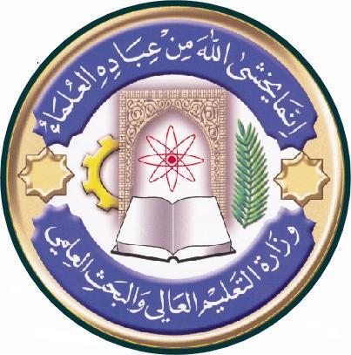
University:alnahrain
College:medicine
Department: Histology &embryology
Stage:Two
Lecturer name: May F.M Al Habib
Academic Status: Professor
Qualification: Ph. D
Place of work:Al Nahrain medical college

Republic of Iraq
The Ministry of Higher Education
& Scientific Research

Course Weekly Outline

Course Instructor | May Fadhil Majid AL Habib
E_mail | Mayalhabib@colmed-alnarain.edu.iq
Title | Professor
Course Coordinator | May Fadhil Majid AL Habib
Course Objective | - To acquire knowledge about primary tissue and their constituent.  - Establish a base to understand the histology of some body systems and organs and their relevance to their functions
Course Description | First semester
Textbook | - Junqueira LC & Carneiro J (2005): Basic Histology; Text & Atlas. 11th ed. McGraw-Hill Medical. New York.
References | - Leeson TS, Leeson CR & Paparo AA (1988): Text/Atlas of Histology. WB Saunders. USA.
Course Assessment | Mid-Term Tests | Laboratory | Quizzes | Project | Final Exam
 | (20%) | (10%) | (10%) | ---- | (60%)
General Notes

University:alnahrain
College:medicine
Department: Histology &embryology
Stage:Two
Lecturer name: May F.M Al Habib
Academic Status: Professor
Qualification: Ph. D
Place of work: Al Nahrain medical college

Republic of Iraq
The Ministry of Higher Education
& Scientific Research

Course weekly Outline
week | Date | Topics Covered | Lab. Experiment Assignments | Notes
1 | 21  September | What is histlogy. General informations about light micrscopy. The major 4 basic tissue, General features | Introduction, how to prepare a histological slid  Epithelial tissue, simple and compound.
2 | 22  September | Characteristics of epithelial tissue, classification & function.  Membranes and cell adhesion & cell surface specialization.
3 | 28  September | Epithelial Exocrine glands. | Epithelial exocrine gland  Simple connective tissue, types of cells
4 | 29  September | Connective tissue: ground substance, fibers. Cells of connective tissue.
5 |  | Eid Al Adha
6 |  | Eid Al Adha
7 | 12  October | Types of connective tissue; Dens, lose, Adipose tissue (unilocular & multilocular). | Loos and dense, adipose tissue, tendons, ligament.
8 | 13  October | Blood: cells, formed elements., types of cells
9 | 19  October | Hematopoiesis; stem cells maturation of erythrocytes, granyolocytes, lymphocytes & monocytes, origin of platelets. | Blood cells Haemopoietic tissue. Bone marrow examination
10 | 20  October | Bone: cells, matrix, types of bones.
11 | 26  October | Bone histogensis, ossification, growth & remodeling. | Bone. Types of bone, cells and arrangement.  Bone ossification Cartilage hyaline, elastic & fibrocartilage
12 | 27  October | Cartilage; hyaline, elastic & fibrocartilage, histogensis of cartilage.
13 | 2  November | Muscle tissue: structure, Cardiac muscle & smooth muscle. | Muscles, cardiac and smooth.
14 | 3  November | skeletal muscle cells, myofibrils, myofiliments,
15 | 9  November | contraction mechanism & innervation (neuromuscular junction | Nervous tissue Types of Nerve cells , sections in the nerve
16 | 10  November | Nervous tissue: histogenesis, cells, fibers, myelination and synapses.
17 | 16  November | Nerve fibers, nerves, ganglia | Practical midterm Exam
18 | 17  November | Theoretical Examination
19 | 23  November | Cerebrum, cerebellum and spinal cord. | Sections in Cerebrum, cerebellum and spinal cord.
20 | 24  November | Membranes covering the CNS, formation of CSF, and blood-brain barrier.
21 | 1  December | Skin: Epidermis, Dermis and Subcutaneous Tissue. | Thin and thick skin. Sections in
22 | 2  December | Skin appendages, glands in the skin
23 | 7  December | Hair and Hair follicle. | hair and hair follicles
24 | 8  December | The Circulatory System and Capillaries.
25 | 14  December | Heart, and its conductive system. | Blood vessels; aorta, vena cava, muscular arteries and accompanying veins, Heart and Purkinje fibers
26 | 15  December | AV anastomosis, arteries, Veins and lymph vessels.
27 | 21  December | Diffuse and nodular lymphatic tissue, B & T-lymphocytes. | Lymphoid organs; Lymph Nodes & Tonsils.
28 | 22  December | Lymph Nodes & Tonsils.
29 | 28  December | Thymus, gut associated lymph tissue & spleen. | Thymus & Spleen.  Re-examining slides
30 | 29  December | Revision and Overview.

Instructor Signature: Dean Signature:

